Sporting Schools - The Basics

Australian primary schools can apply for funding to deliver a Sporting Schools activity before, during or after school hours. Let’s Ride is one of these programs.
Schools can apply for funds to have Let’s Ride delivered by a coach or internally by a teacher.
To be eligible and apply for funding, your school needs to:
- Complete school registration *ensure Principal signs off registration to complete process;
- Have primary school-aged children enrolled at the school;
- Provide a Finance Contact for the school;
- Provide valid bank account details;
- Declare if the school is a Government Related Entity (GRE); and
- Have no outstanding debts with the Australian Sports Commission.
Once the school is registered with Sporting Schools, the application process should take no longer than 10 minutes to complete. The outcome of your school’s application should be known in 10 business days.
Schools can apply for as many sports as they like per term, it just depends on how far the grant amount will stretch. Funding amounts per term are based on:
- School population;
- The total number of participants scheduled to participate in the Sporting Schools sessions; and
- Any applicable special circumstances (such as regional and remote schools).
Once your funding is approved you can use the online booking system to book sports packages including Let’s Ride packages from Cycling Australia.
Two packages are available:
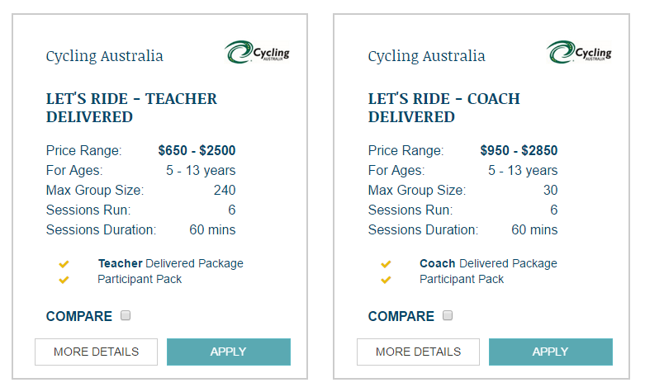
Let’s Ride - Teacher Delivered
Learning to ride is a rite of passage, but learning to ride safely is a skill that children need to be taught. With more than 1.9 million Australian children riding their bikes every week, Cycling Australia (CA) has launched Let’s Ride to bridge the gap between riding and riding responsibly.
Let’s Ride is a is a fun and interactive learning experience that teaches kids to ride safely by developing their knowledge, skills and confidence – supporting kids in their independence and giving parents peace of mind.
Let’s Ride is a six-week program, held on school grounds, that can be delivered before, during or after school. The Let’s Ride program has been innovatively linked to the new national PDHPE curriculum to ensure that your curriculum outcomes can be met. Visit www.cycling.org.au/curriculum for more information.
Program Structure
Let’s Ride is split into two levels or ‘gears’:
- 2nd Gear (introductory) focuses on bike control skills, so that kids are given the techniques to enable them to ride more proficiently in a traffic-free environment (park, backyard, around the block, etc.)
- 3rd Gear (advanced) focuses on riding and situational awareness, so that kids are given the competencies to enable them to ride safely in low-traffic environments (shared paths, footpaths, bike paths, quiet streets, etc.)
Teacher Delivery
Cycling Australia will provide your school with a comprehensive, yet easy to use, Let’s Ride Delivery Pack that contains all of the resources and content required to deliver the Let’s Ride program.
The content has been developed so that no prior coaching experience in cycling is required.
The Let’s Ride Delivery Pack includes the following resources:
- Let’s Ride Session Plans, including complete session plan booklet and summary cards
- Let’s Ride Delivery Resources, including cue cards, signage and approval stickers
- Access to the online registration and communication platform – weekly communication of at-home skills and extension activities will be automatically sent to parents upon completion of the session
- Participant pack for all participants, including progression tracker (linked to the content and weekly at-home activities), drawstring bag, cycling cap and bike/helmet decal stickers.
The cost of the Let’s Ride Delivery Pack is based on the number of participants involved in the program:
Number of Participants | Cost
10-29 | $650
30-49 | $900
50-79 | $1,350
80-99 | $1,650
100-150 | $2,500

Let’s Ride - Coach Delivered
Learning to ride is a rite of passage, but learning to ride safely is a skill that children need to be taught. With more than 1.9 million Australian children riding their bikes every week, Cycling Australia (CA) has launched Let’s Ride to bridge the gap between riding and riding responsibly.
Let’s Ride is a is a fun and interactive learning experience that teaches kids to ride safely by developing their knowledge, skills and confidence – supporting kids in their independence and giving parents peace of mind.
Let’s Ride is a six-week program, held on school grounds, that can be delivered before, during or after school. The Let’s Ride program has been innovatively linked to the new national PDHPE curriculum to ensure that your curriculum outcomes can be met. Visit www.cycling.org.au/curriculum for more information.
Program Structure
Let’s Ride is split into two levels or ‘gears’:
- 2nd Gear (introductory) focuses on bike control skills, so that kids are given the techniques to enable them to ride more proficiently in a traffic-free environment (park, backyard, around the block, etc.)
- 3rd Gear (advanced) focuses on riding and situational awareness, so that kids are given the competencies to enable them to ride safely in low-traffic environments (shared paths, footpaths, bike paths, quiet streets, etc.)

Coach Delivery
An accredited Delivery Centre with qualified instructors can come to your school to deliver the six-week program before, during or after school hours. Programs will run with a minimum of 10 participants and a maximum of 15 participants per instructor.
The cost per participant is $95.

