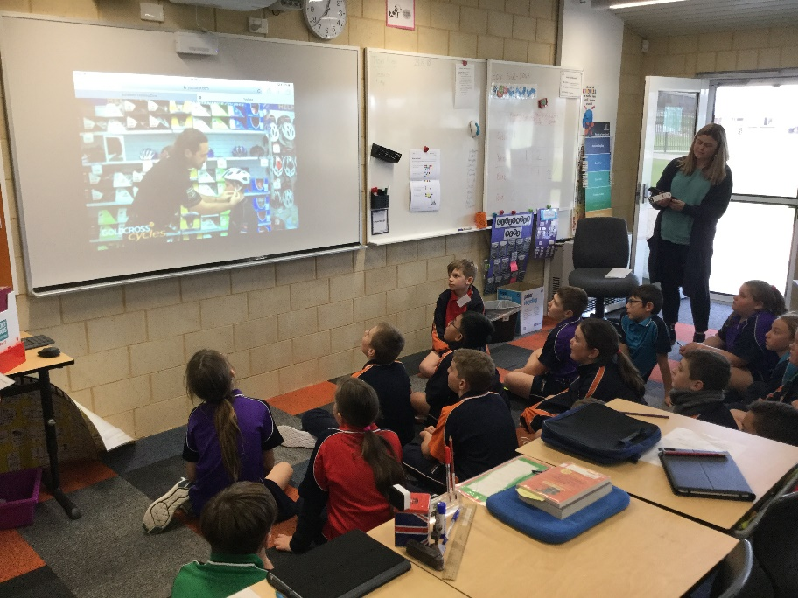
Watching a video of how to wear a helmet correctly.
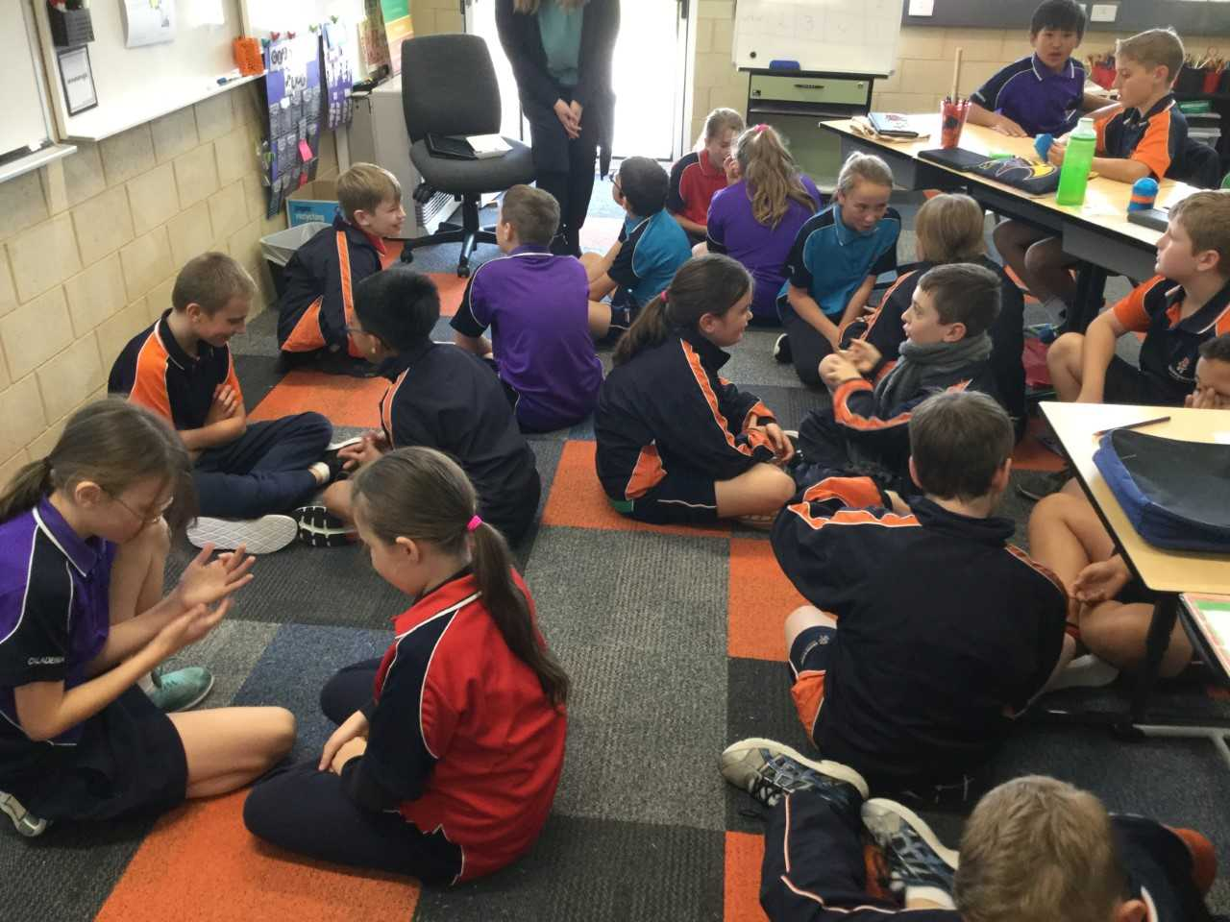

Think, Pair, Share Activity
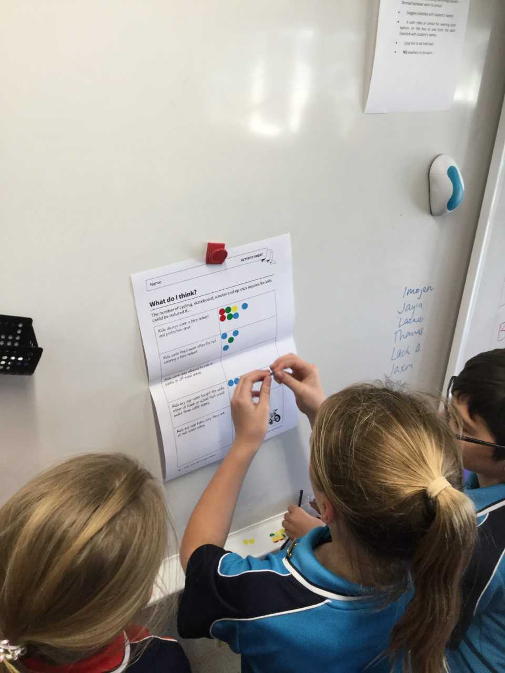

Students completing the Survey

