Active Travel Week
As the school year draws to an end and the weather warms up, it’s a great opportunity to think about the different ways we travel to school.

We would like to promote the coming week as “ACTIVE TRAVEL WEEK”
So grease those chains, adjust the brakes, clip on the helmet and cycle to school. Find your scooter, adjust the handle bars and scoot in to school, or tie up the laces and walk to school.
Find a group of friends to travel with, plan the safest route and let’s all be active in how we travel to school.
Biking, Scooting and Walking are all healthy ways to get to school and home again.

A survey will be conducted by the Year Sixes and the data used and interpreted will be part of an assignment they have completed.

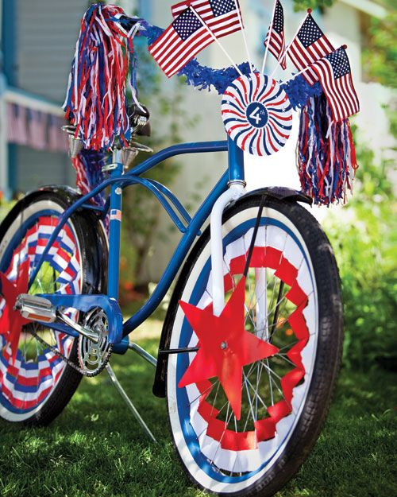
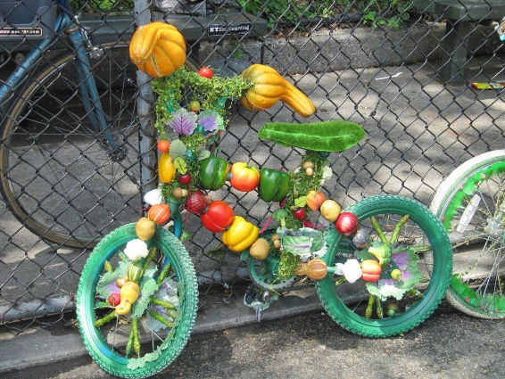
For a fun activity: THIS FRIDAY 23RD NOVEMBER, DRESS UP YOUR BIKE DAY!!Dress up and decorate your bike using your creative imagination, then ride or take your bike to school for a fancy bike show and competition.

