Your Move run by the Department of Transport that schools to help reduce car use , take up more walking, bike riding, and public transport trips to get around.

- Stories are submitted, including photos etc of any activity related to promoting road safety / promoting active travel / bike safety or lessons etc to Your Move.
- Every story and photo is awarded points. The points equate to unlocking grants.
- This year we are aiming to unlock a grant to get some more bike racks installed near C Block.
- If we are lucky enough to make 1500 points this term (which will be hard) we can unlock the grant below.
- Points only last for the year so we have this term to try and meet our goal.

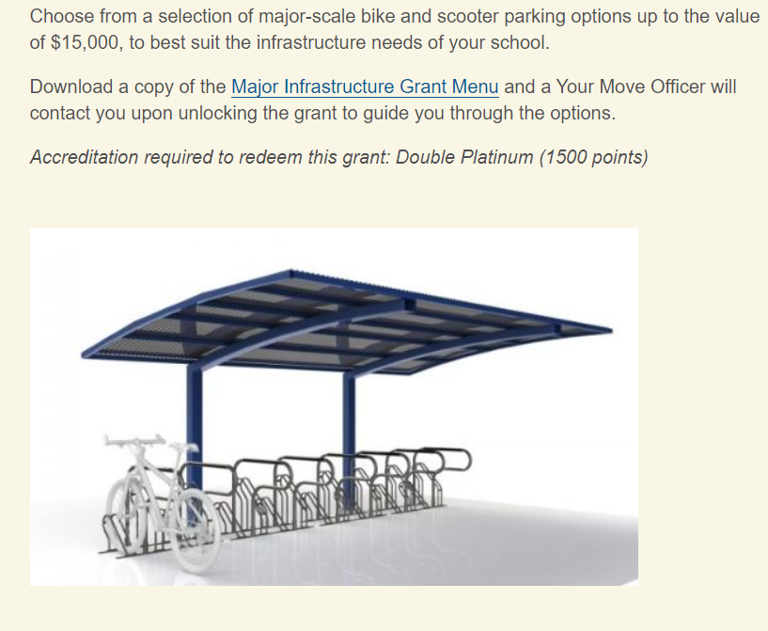
Some suggestions for activities include….
The great driving kids to school debate | Bike Education Sessions
Class collage on road safety | Classroom road safety lessons
Research transport through photographs | Promote public transport options
Think Global Act Local | Promote bike facilities
Dress up your bike day | Article in the school newsletter
Promote wheels on Wednesday | Promote active travel
Slow bike race and obstacle course event | Kindy talk on road safety
Bike maintenance and repair workshop | CO2 experiment and the greenhouse effect

PROMOTING WHEELS ON WEDNESDAY

WEEK | ACTIVITIES FOR WHEELS ON WEDNESDAY
2
3 | Ride or walk to school- Wednesday.  Student Councillors award stickers to all students who ride or walk to school
4 | Dress up your bike day- spot prize for 1 student
5 | Bike Obstacle course
6 | Bike maintenance /repair workshop
7 | Bike race in year levels
8 | Ride or walk to school- Wednesday. Raffle tickets awarded to students who ride, walk or scoot to school. Three raffle tickets drawn out for prizes.
9 | Student Winners of the bike race verse staff
10 | Decorate your bike for Christmas.

